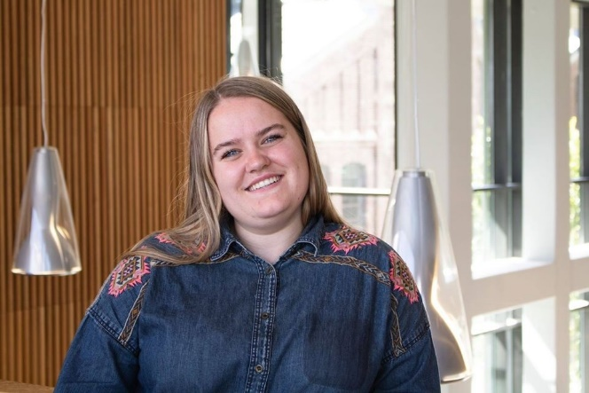
Hello!
My name is Helene and I am 24 years old. I am now in my second year here at NMBU, and I enjoy it here very much. I started here at NMBU in 2020, at economics and administration, but this semester I have taken individual courses at HH. From before, I have completed a bachelor's degree in nursing at the University College of Western Norway (HVL).
I would describe myself as bubbly, engaged and cheerful, but also not afraid to let people know if I am not happy with something! My motto is that; all that is good, can always get better. This is also what motivates me in my work, and which makes me constantly find something to work towards. If I think something is unfair or could get better, then I get involved easily. This will probably be one of my strengths in AU.
My biggest matter of the heart is student engagement. Universities were greatly affected by corona, partly due to a lot of digital teaching. This has made it difficult for students to become part of the classroom environment, but also to get to know the study place and all its possibilities. For a place like NMBU with a strong student commitment, it is important that we do not lose opportunities as a consequence of corona. I want the vast majority of students to be able to find a place where they can get involved, whether it is association, society, student politics or other places.
I have a lot of previous experience in both politics and student politics. My political career first began in a youth party. However, most of my experience comes from HVL. At HVL I sat 2 years in the learning environment committee, 2.5 years in the student parliament, 1 year as AU at the student parliament and 1 year in the campus council (corresponding student council), among other things. Here at NMBU, I was on the committee for line association for about 6 months, I’ve been funksjonær during UKA 2020 and 2022 and I now currently sit in the Student Parliament. I am also involved in the association Sangkoret Lærken.
The experiences from previous and present positions will be a strength that I can take with me into an AU. With the experiences I have from the Student Parliament at HVL, I am well acquainted with student democracy in general and board work in particular. This experience can and does give me other perspectives on the Student Parliament here at NMBU.
So to answer the most important thing, why should you vote for me in this election? Because I have the commitment, experience and motivation to work for the students next year! I hope you will give me the opportunity to work for the students next year!
If you have any questions or just want to have a chat, just grab me when you see me or contact me on Facebook😊
Good election!
Helene Sylvarnes
helene.sylvarnes@nmbu.no
9777485

