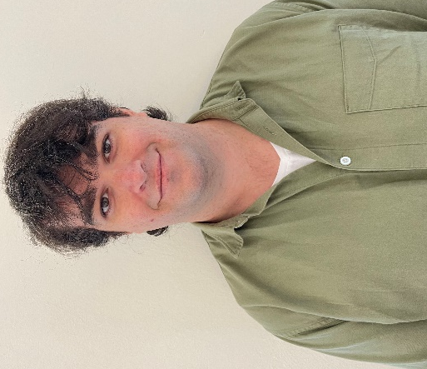
"Dear students,
I hereby run for the leader of the Student Democracy's Student Board. My name is Magnus Azevedo Stirø, and I am taking a master’s degree in International Relations. I also hold a bachelor’s in International Studies with History from Inland University College (INN). The past two years I have been the leader of SAIH Ås, the local chapter of the Norwegian Students’ and Academics’ International Assistance Fund at NMBU. In addition, I have been the leader of the student bar at INN Lillehammer and intern at the Norwegian Embassy in Kosovo.

NMBU is facing an important year. Hopefully, the coming school year will be the first in a while without restrictions. Therefore, it is imperative to ensure a pleasant, inclusive, and safe study experience for everyone is important. Campus must be an inclusive space, accommodating to be a meeting place both academically and socially. NMBU does not only have Norway’s finest campus, but also a student environment which is unparalleled in this country. The Student Democracy must be on the ball to ensure that the student environment flourishes and that NMBU is a place where all students feel included and valued.

The university is constantly developing. The Student Board and Student Democracy play a vital role in how the future NMBU will look like. Then it is important to get the students’ perspectives to ensure that the development happens on student terms. Without a good information flow, the student parliament cases stop up at a faculty level without much transparency. I will use my experience from information work to reach out to as many as possible. With this I want to ensure that students get a good overview of cases which concerns them, as well as their rights, and that they get something back from the trust given to their representatives.

NMBU likes to call itself Norway’s most international university. Internationalization affects not only research cooperation and exchange possibilities, but also NMBU’s student mass. It is important to ensure that all students arriving at NMBU feel seen and that their worries and needs are taken seriously. The Student Democracy must work so that both NMBU and the Student Democracy are attentive to and accommodating for the needs of international students and work closely with organizations such as ISU and ESN.

The world around us is constantly changing. NMBU plays an important part in educating competent people to face the biggest challenge of all time — climate change. Promoting sustainable solutions and innovations on all levels is vital. Greener focus in teaching, research, and measures on campus must continue to be priority areas. NMBU has a good staring point but can become even better in the execution. Climate change is a great concern among many students. Therefore, the Student Democracy must be a driving force for NMBU to become even greener.

I have broad organizational and leadership experience. This will come in handy in the role as a leader, developing NMBU’s student democracy and taking on the responsibility that comes with the role. I am motivated to represent every single student and that our great university becomes even more inclusive, greener, and progressive. If elected, you will get a leader with great commitment who will fight for students’ rights and needs. If I am worthy of your trust, I will give everything to make Ås an even better place to be a student with a strengthened student democracy.
" Magnus Azevedo Stirø
magnus.azevedo.stiro@nmbu.no
92245660

