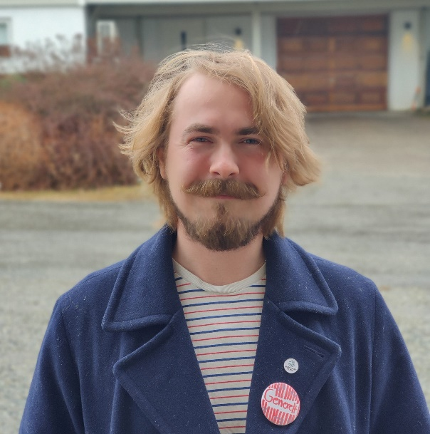
""Dear fellow students!

My name is Wilhelm Anthun, and I am hereby running for the position as leader of the working committee (AU) of the student parliament. I am 23 years old, have completed a bachelor’s degree in biology, and I have lived in Ås for four years now.

As leader of AU I will be using the knowledge and experiences I have gathered through a lot of different engagements in the student democracy, student-organizations and in my spare time. It is also the sum of these experiences that makes me want to run. I have been a student representative in the faculty board of BIOVIT, representative in the student parliament, and I have collaborated in arranging a public meeting and climate strike. Currently, I am one of two sitting speakers in the student parliament, and I also hold the position as vice-representative to the University board.

AU tackles an abundance of different cases and problems that has to be solved, but I want to highlight these as Important to me: Student well-being, the dialogue between the student mass and the student parliament, and NMBUs completion of their sustainability promises.

The SHoT-study (a study of student health) will be publishing their results in the coming academic year, and earlier studies have shown that over fifty percent of students experience loneliness. This years results must be taken very seriously by the university, Samfunnet, SIÅS and the student democracy, and we all must do what we can to lower these numbers. Complex problems like these requires an ocean of different solutions, but I believe that one of the most important thing one can do is to make arenas where one can discuss and reflect about the problems one is facing. This is true for everyone, but especially people in positions of social power in student organisations, classes, collectives, and groups of friends.

Communication is alfa and omega in most situations, and I whish that the dialogue between the student democracy and the student mass shall become ever better. If the parliament and the student councils are to function as expected, they must understand how the student mass is feeling about things. As the parliament is supposed to represent all students, it is important to me that as many as possible understand what goes on in there. To achieve this, I believe that we must look to our class representatives. Their role must not be underestimated, as they are the students first meeting with the student democracy. Their role should be concretized, they should be more connected to the student council, and one must assure that each class has always has a representative.

NMBU is the university of sustainability. This must be reflected in all decisions, at every level, especially when planning the development of the eastern part of the campus. I expect this to become a showcase of sustainable solutions. As leader of AU I will be doing what I can to make sure that the university will deliver on its promises of sustainability.

I have lived in Ås the last four years, but it is all the fantastic people I have met that has made it my home. I know the importance of having good people close by, and I hope that I can help to make a student environment that more people feel like they can call their home.

I wish everyone a good election, and I hope that I have made myself deserving of your vote
Wilhelm Olav Anthun
wilhelm.anthun@nmbu.no
48185922

